3.

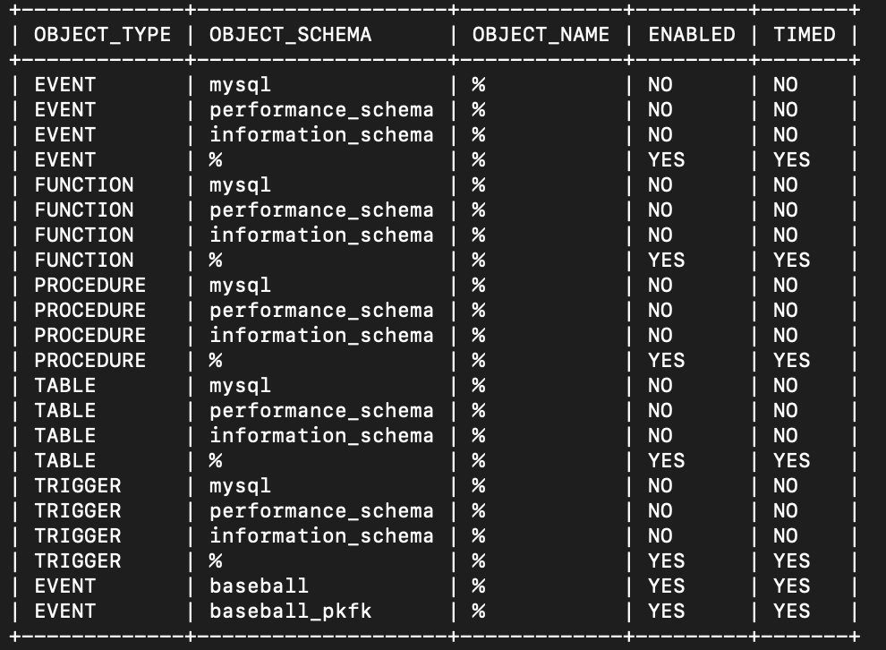

a)

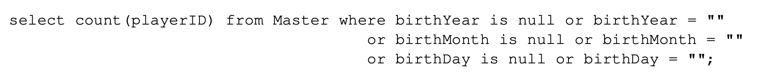

**Without any index:**

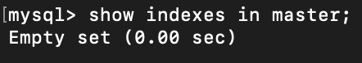

**First experiment:**

timer_start = 2670250977689000000

timer_end = 2670250989851000000

timer_wait = 12162000000

**Second experiment:**

timer_start = 2670348410393000000

timer_end = 2670348422958000000

timer_wait = 12565000000

**Third experiment:**

timer_start = 2670525774194000000

timer_end = 2670525787571000000

timer_wait = 13377000000

**Fourth experiment:**

timer_start = 2670550071715000000

timer_end = 2670550084205000000

timer_wait = 12490000000

**Fifth experiment:**

timer_start = 2670555884274000000

timer_end = 2670555896913000000

timer_wait = 12639000000

average = 12646600000 picoseconds = 12646.6 microseconds

min = 12162000000 picoseconds = 12162 microseconds

max = 13377000000 picoseconds = 13377 microseconds

**With primary key:**



**First experiment:**

timer_start = 2675058847276000000

timer_end = 2675058855635000000

timer_wait = 8359000000

**Second experiment:**

timer_start = 2675062205187000000

timer_end = 2675062213872000000

timer_wait = 8685000000

**Third experiment:**

timer_start = 2675063213317000000

timer_end = 2675063221973000000

timer_wait = 8656000000

**Fourth experiment:**

timer_start = 2675064631861000000

timer_end = 2675064640297000000

timer_wait = 8436000000

**Fifth experiment:**

timer_start = 2675088920187000000

timer_end = 2675088929092000000

timer_wait = 8905000000

average = 8608200000 picoseconds = 8608.2 microseconds

min = 8359000000 picoseconds = 8359 microseconds

max = 8905000000 picoseconds = 8905 microseconds

**With index:**

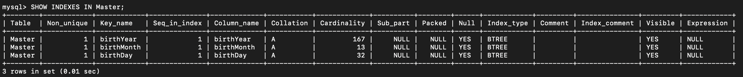

**First experiment:**

timer_start = 2675743402738000000

timer_end = 2675743404700000000

timer_wait = 1962000000

**Second experiment:**

timer_start = 2675744157658000000

timer_end = 2675744159643000000

timer_wait = 1985000000

**Third experiment:**

timer_start = 2675744805937000000

timer_end = 2675744807899000000

timer_wait = 1962000000

**Fourth experiment:**

timer_start = 2675745461413000000

timer_end = 2675745463393000000

timer_wait = 1980000000

**Fifth experiment:**

timer_start = 2675746079171000000

timer_end = 2675746081219000000

timer_wait = 2048000000

average = 1987400000 picoseconds = 1987.4 microseconds

min = 1962000000 picoseconds = 1962 microseconds

max = 2048000000 picoseconds = 2048 microseconds

b)

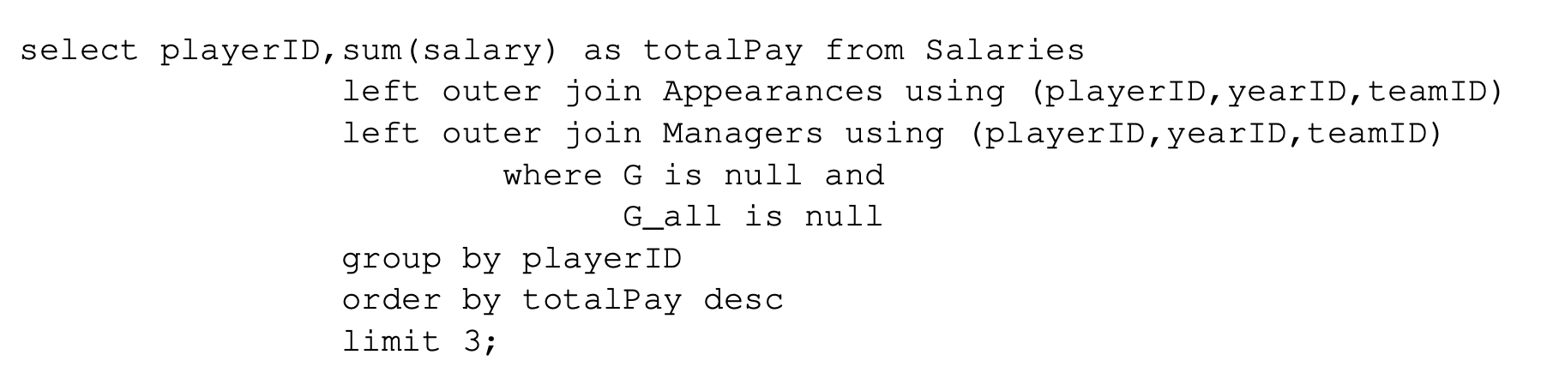

**Without any index:**

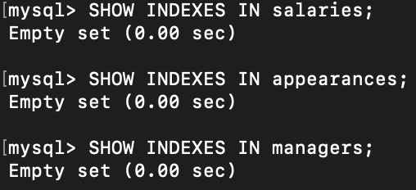

**First experiment:**

timer_start = 2676497028819000000

timer_end = 2676497340486000000

timer_wait = 311667000000

**Second experiment:**

timer_start = 2676496057829000000

timer_end = 2676496379061000000

timer_wait = 321232000000

**Third experiment:**

timer_start = 2676495180931000000

timer_end = 2676495491202000000

timer_wait = 310271000000

**Fourth experiment:**

timer_start = 2676494271010000000

timer_end = 2676494588133000000

timer_wait = 317123000000

**Fifth experiment:**

timer_start = 2676493302192000000

timer_end = 2676493625012000000

timer_wait = 322820000000

average = 316622600000 picoseconds = 316622.6 microseconds

min = 310271000000 picoseconds = 310271 microseconds

max = 322820000000 picoseconds = 322820 microseconds

**With primary key:**

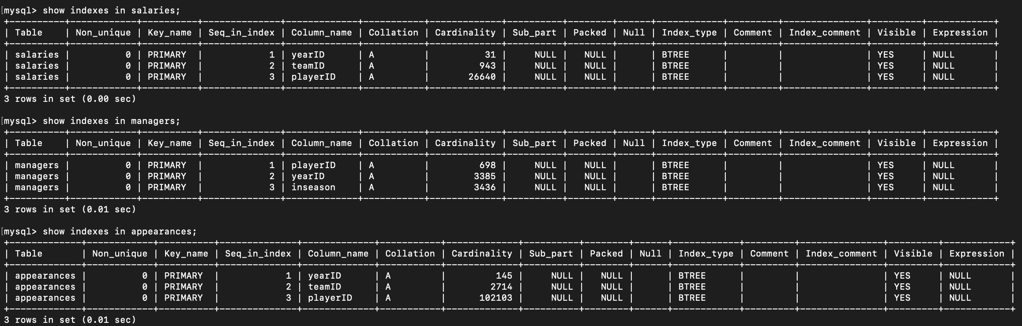

**First experiment:**

timer_start = 2677709783933000000

timer_end = 2677709869826000000

timer_wait = 85893000000

**Second experiment:**

timer_start = 2677708600213000000

timer_end = 2677708680463000000

timer_wait = 80250000000

**Third experiment:**

timer_start = 2677708079932000000

timer_end = 2677708162571000000

timer_wait = 82639000000

**Fourth experiment:**

timer_start = 2677707513975000000

timer_end = 2677707594072000000

timer_wait = 80097000000

**Fifth experiment:**

timer_start = 2677706907731000000

timer_end = 2677706988923000000

timer_wait = 81192000000

average = 82014200000 picoseconds = 82014.2 microseconds

min = 80097000000 picoseconds = 80097 microseconds

max = 85893000000 picoseconds = 85893 microseconds

**With primary key and foreign key:**

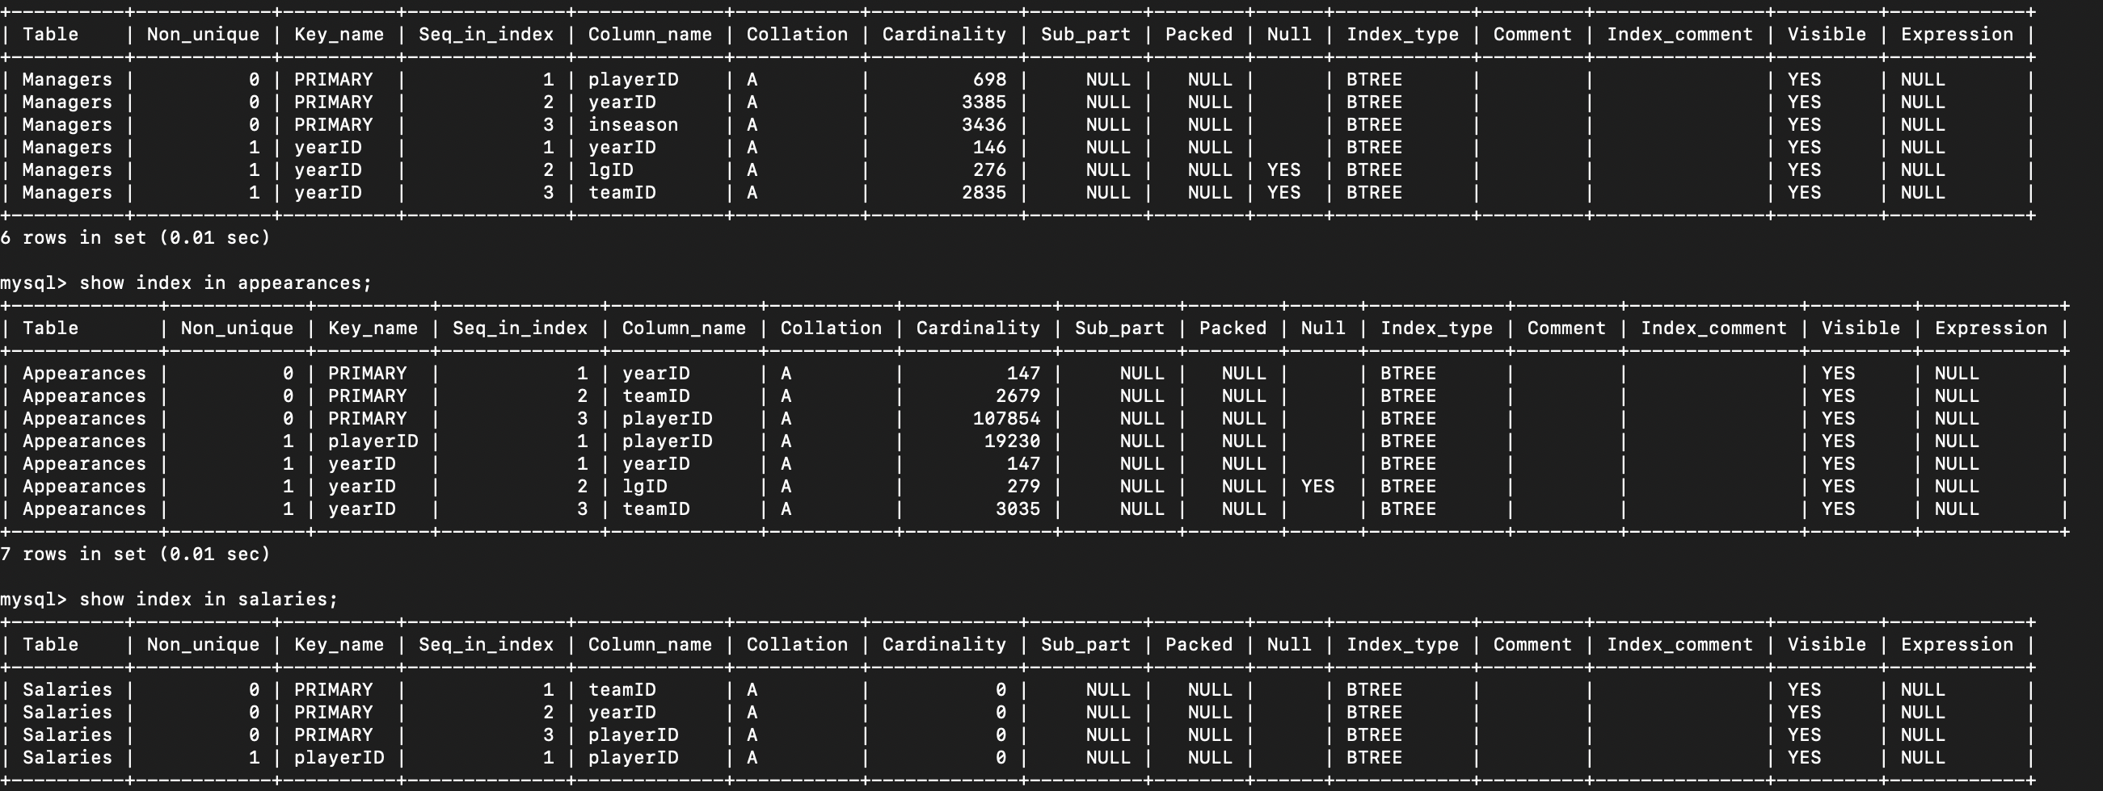

**First experiment:**

timer_start = 2679589034687000000

timer_end = 2679589124798000000

timer_wait = 90111000000

**Second experiment:**

timer_start = 2679588291542000000

timer_end = 2679588379969000000

timer_wait = 88427000000

**Third experiment:**

timer_start = 2679587375741000000

timer_end = 2679587466515000000

timer_wait = 90774000000

**Fourth experiment:**

timer_start = 2679586831826000000

timer_end = 2679586921074000000

timer_wait = 89248000000

**Fifth experiment:**

timer_start = 2679586235626000000

timer_end = 2679586327892000000

timer_wait = 92266000000

average = 90165200000 picoseconds = 90165.2 microseconds

min = 88427000000 picoseconds = 88427 microseconds

max = 92266000000 picoseconds = 92266 microseconds

**With index:**

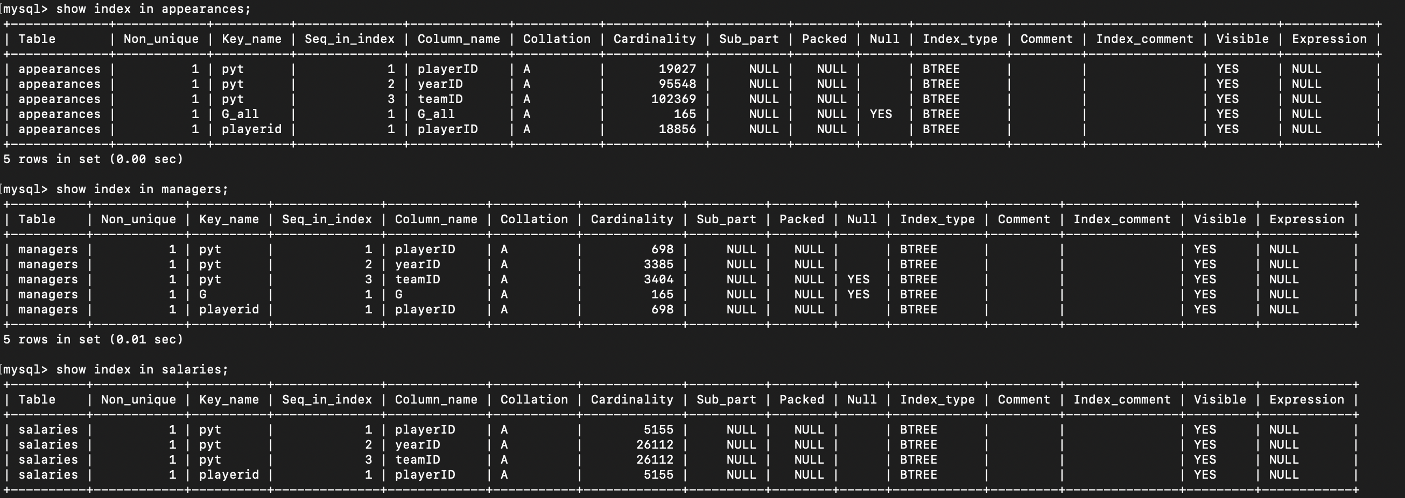

**First experiment:**

timer_start = 2689287400445000000

timer_end = 2689287505777000000

timer_wait = 105332000000

**Second experiment:**

timer_start = 2689287016687000000

timer_end = 2689287124894000000

timer_wait = 108207000000

**Third experiment:**

timer_start = 2689286667599000000

timer_end = 2689286773869000000

timer_wait = 106270000000

**Fourth experiment:**

timer_start = 2689286336748000000

timer_end = 2689286440624000000

timer_wait = 103876000000

**Fifth experiment:**

timer_start = 2689285988301000000

timer_end = 2689286092579000000

timer_wait = 104278000000

average = 105592600000 picoseconds = 105592.6 microseconds

min = 103876000000 picoseconds = 103876 microseconds

max = 108207000000 picoseconds = 108207 microseconds

c)



**Without any index:**

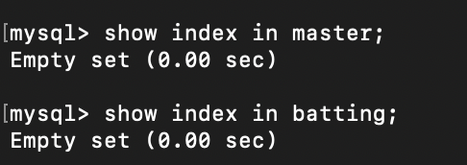

**First experiment:**

timer_start = 2683521168869000000

timer_end = 2683521322099000000

timer_wait = 153230000000

**Second experiment:**

timer_start = 2683520522006000000

timer_end = 2683520676959000000

timer_wait = 154953000000

**Third experiment:**

timer_start = 2683519868334000000

timer_end = 2683520022897000000

timer_wait = 154563000000

**Fourth experiment:**

timer_start = 2683519259727000000

timer_end = 2683519417296000000

timer_wait = 157569000000

**Fifth experiment:**

timer_start = 2683518577026000000

timer_end = 2683518734890000000

timer_wait = 157864000000

average = 155635800000 picoseconds = 155635.8 microseconds

min = 153230000000 picoseconds = 153230 microseconds

max = 157864000000 picoseconds = 157864 microseconds

**With primary key:**

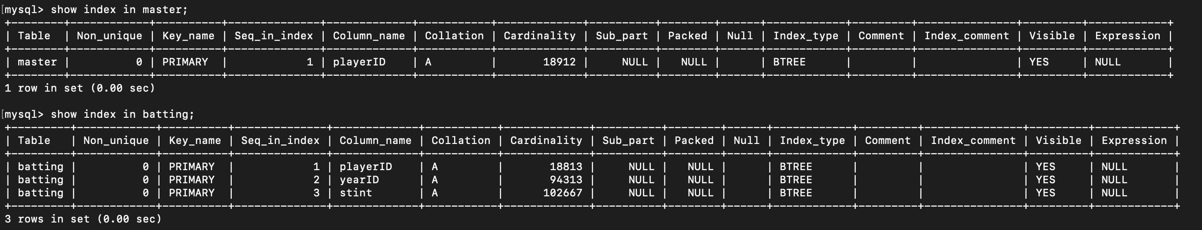

**First experiment:**

timer_start = 268390954034400000

timer_end = 2683909667638000000

timer_wait = 127294000000

**Second experiment:**

timer_start = 2683908961224000000

timer_end = 2683909090418000000

timer_wait = 129194000000

**Third experiment:**

timer_start = 2683908381386000000

timer_end = 2683908515736000000

timer_wait = 134350000000

**Fourth experiment:**

timer_start = 2683907772178000000

timer_end = 2683907901779000000

timer_wait = 129601000000

**Fifth experiment:**

timer_start = 2683907151329000000

timer_end = 2683907282132000000

timer_wait = 130803000000

average = 130248400000 picoseconds = 130248.4 microseconds

min = 127294000000 picoseconds = 127294 microseconds

max = 134350000000 picoseconds = 134350 microseconds

**With primary key and foreign key:**

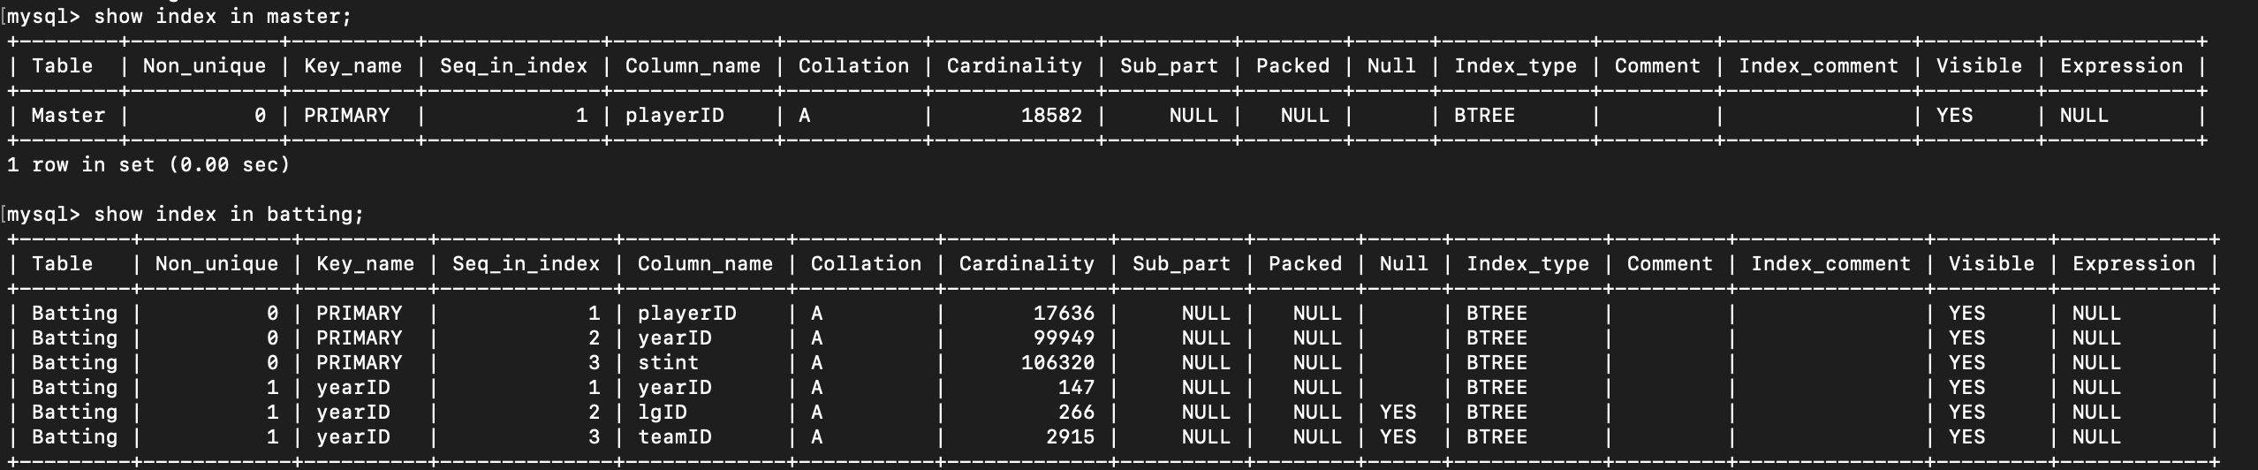

**First experiment:**

timer_start = 2684181067740000000

timer_end = 2684181206596000000

timer_wait = 138856000000

**Second experiment:**

timer_start = 2684180234504000000

timer_end = 2684180372019000000

timer_wait = 137515000000

**Third experiment:**

timer_start = 2684179424129000000

timer_end = 2684179573309000000

timer_wait = 149180000000

**Fourth experiment:**

timer_start = 2684178604558000000

timer_end = 2684178744235000000

timer_wait = 139677000000

**Fifth experiment:**

timer_start = 2684177815742000000

timer_end = 2684177959049000000

timer_wait = 143307000000

average = 141707000000 picoseconds = 141707 microseconds

min = 137515000000 picoseconds = 137515 microseconds

max = 149180000000 picoseconds = 149180 microseconds

**With index:**

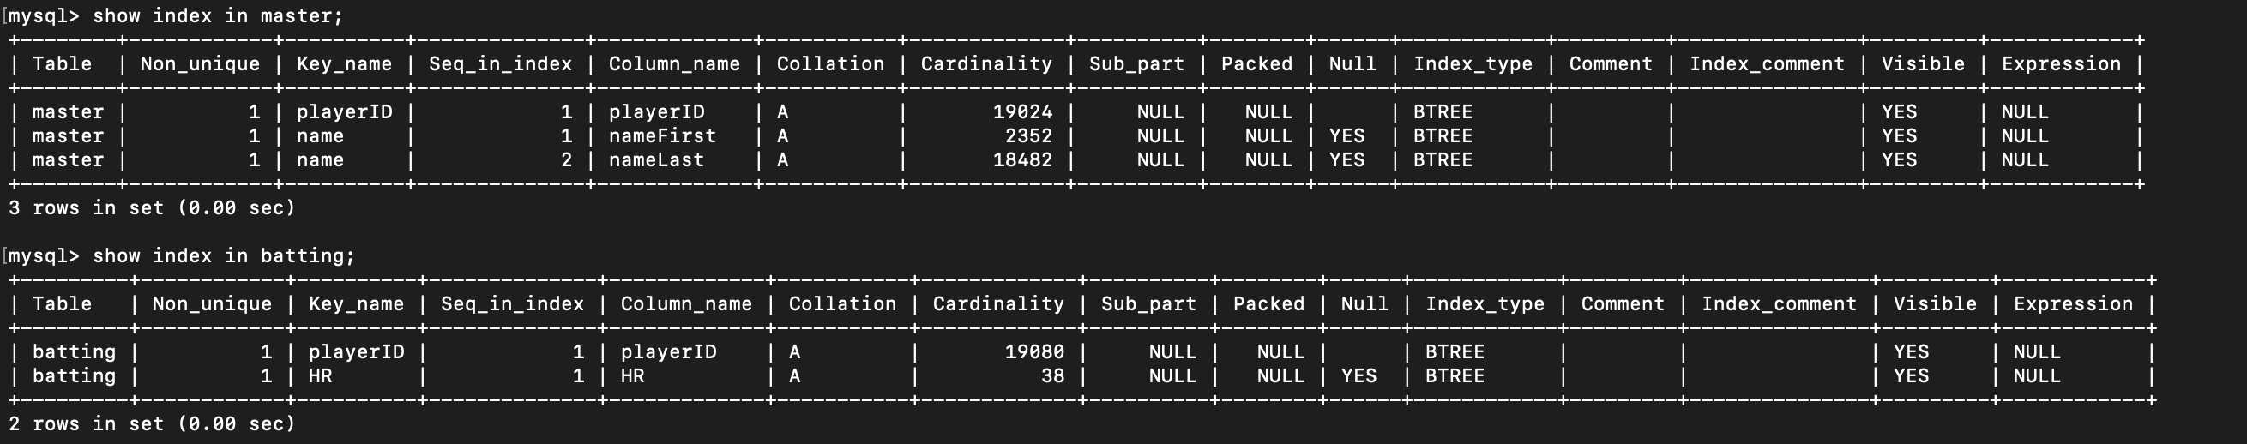

**First experiment:**

timer_start = 2684799712959000000

timer_end = 2684799713174000000

timer_wait = 215000000

**Second experiment:**

timer_start = 2684799200257000000

timer_end = 2684799200467000000

timer_wait = 210000000

**Third experiment:**

timer_start = 2684798677155000000

timer_end = 2684798677367000000

timer_wait = 212000000

**Fourth experiment:**

timer_start = 2684798130838000000

timer_end = 2684798131054000000

timer_wait = 216000000

**Fifth experiment:**

timer_start = 2684797590021000000

timer_end = 2684797590233000000

timer_wait = 212000000

average = 213000000 picoseconds = 213 microseconds

min = 210000000 picoseconds = 210 microseconds

max = 216000000 picoseconds = 216 microseconds

Other combination of index:

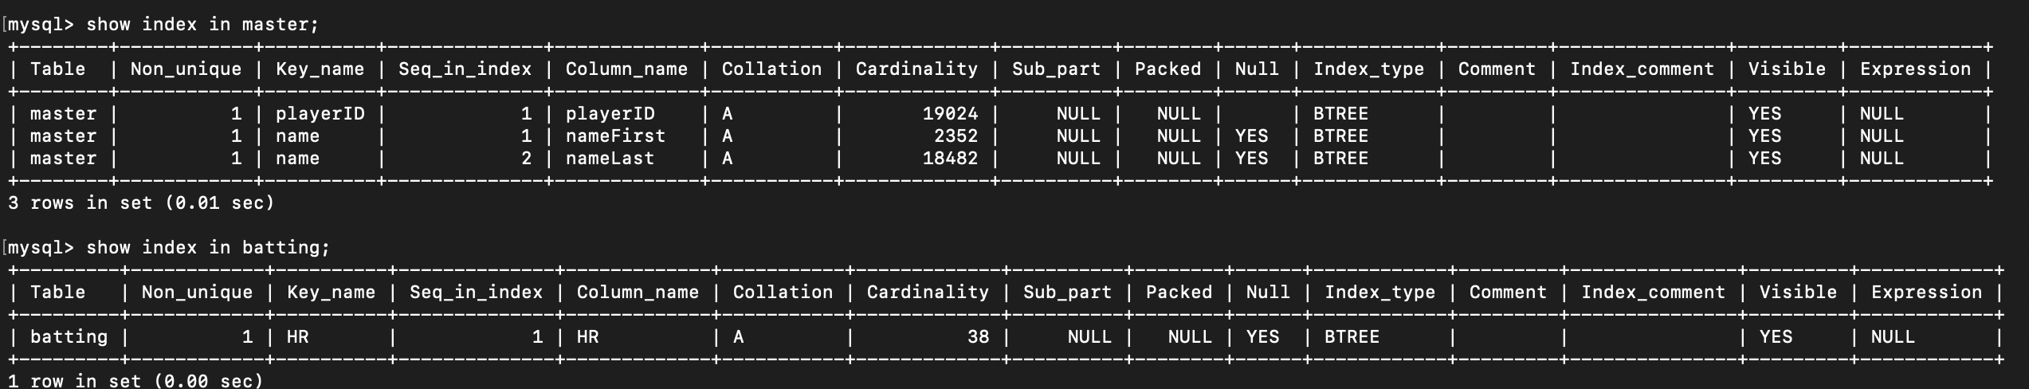

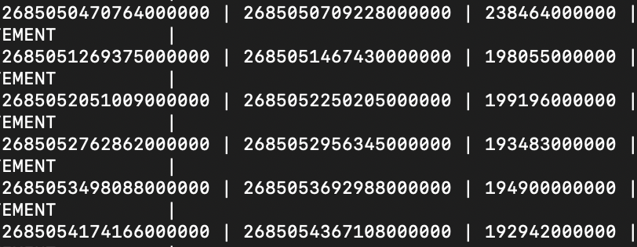

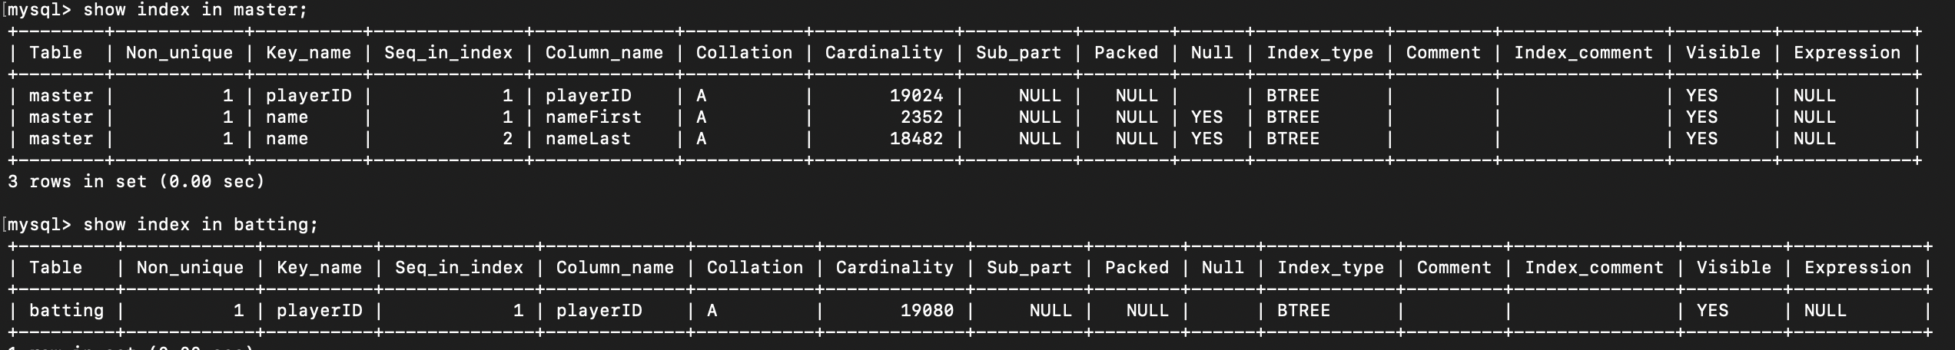

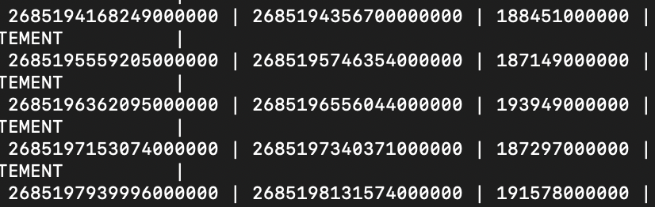

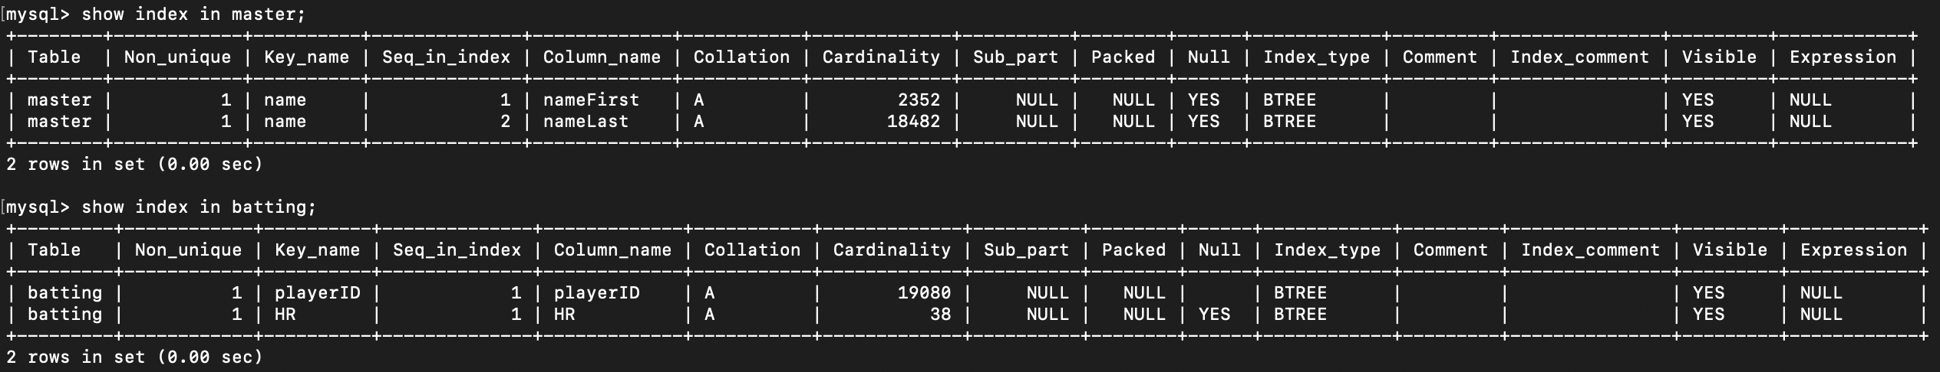

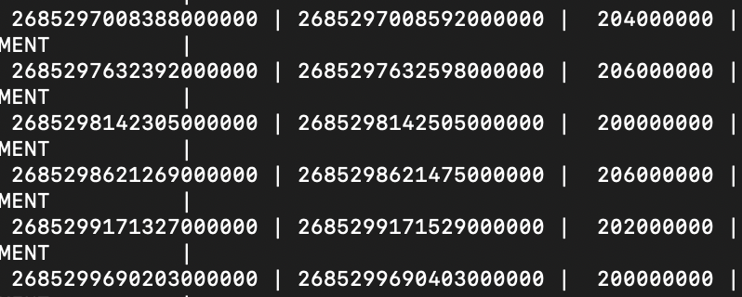

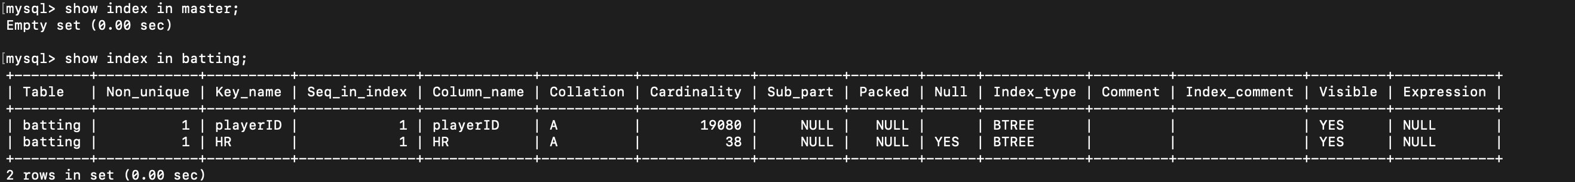

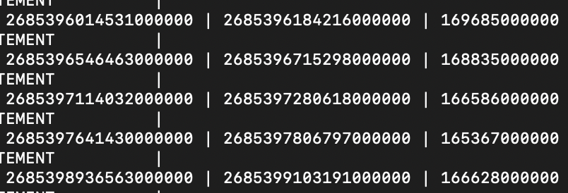

**Conclusion:**



**Without any index:**

average = 12646600000 picoseconds = 12646.6 microseconds

min = 12162000000 picoseconds = 12162 microsecondst

max = 13377000000 picoseconds = 13377 microseconds

**With primary key:**

average = 8608200000 picoseconds = 8608.2 microseconds

min = 8359000000 picoseconds = 8359 microseconds

max = 8905000000 picoseconds = 8905 microseconds

**With index:**

average = 1987400000 picoseconds = 1987.4 microseconds

min = 1962000000 picoseconds = 1962 microseconds

max = 2048000000 picoseconds = 2048 microseconds



**Without any index:**

average = 316622600000 picoseconds = 316622.6 microseconds

min = 310271000000 picoseconds = 310271 microseconds

max = 322820000000 picoseconds = 322820 microseconds

**With primary key:**

average = 82014200000 picoseconds = 82014.2 microseconds

min = 80097000000 picoseconds = 80097 microseconds

max = 85893000000 picoseconds = 85893 microseconds

**With primary key and foreign key:**

average = 90165200000 picoseconds = 90165.2 microseconds

min = 88427000000 picoseconds = 88427 microseconds

max = 92266000000 picoseconds = 92266 microseconds

**With index:**

average = 105592600000 picoseconds = 105592.6 microseconds

min = 103876000000 picoseconds = 103876 microseconds

max = 108207000000 picoseconds = 108207 microseconds



**Without any index:**

average = 155635800000 picoseconds = 155635.8 microseconds

min = 153230000000 picoseconds = 153230 microseconds

max = 157864000000 picoseconds = 157864 microseconds

**With primary key:**

average = 130248400000 picoseconds = 130248.4 microseconds

min = 127294000000 picoseconds = 127294 microseconds

max = 134350000000 picoseconds = 134350 microseconds

**With primary key and foreign key:**

average = 141707000000 picoseconds = 141707 microseconds

min = 137515000000 picoseconds = 137515 microseconds

max = 149180000000 picoseconds = 149180 microseconds

**With index:**

average = 213000000 picoseconds = 213 microseconds

min = 210000000 picoseconds = 210 microseconds

max = 216000000 picoseconds = 216 microseconds

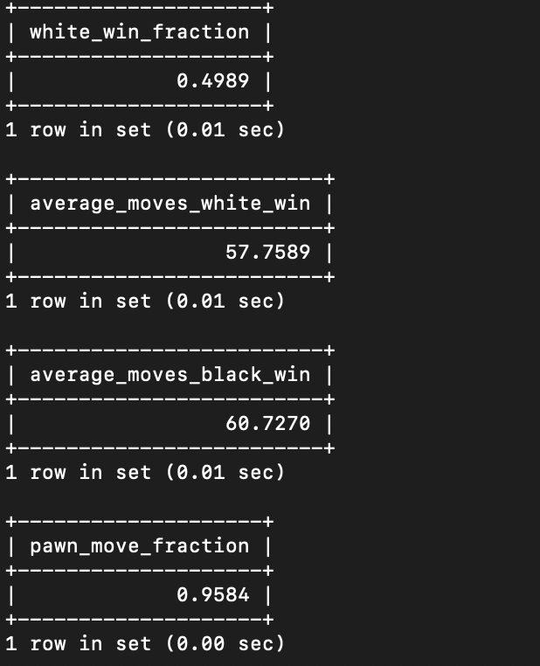

Only involve those games that move knights or bishops or rooks.

